Peripherals and Power Supply

Assignment 1 Day5

TASK1.On your Windows laptop or PC, open 'System Information' and take a screenshot showing your OS version, processor, and RAM details.
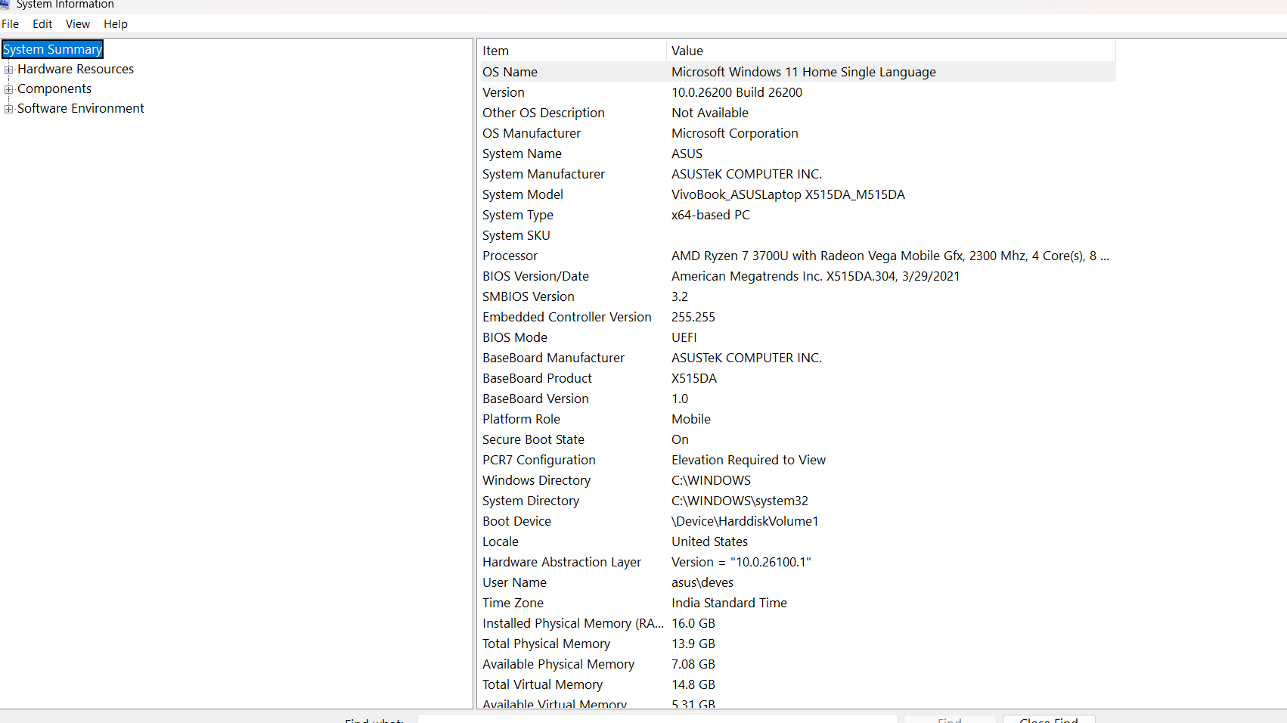
TASK2. Download any official Linux distribution ISO (like Ubuntu or Fedora), and use Rufus or BalenaEtcher to create a bootable USB drive for installation.<br><br><em><strong>Hint:</strong> If you don't have a spare USB, use a virtual machine tool like VirtualBox to mount the ISO and start the installation process virtually.</em>
STEP1- Download ubuntu ISO file
STEP2- Download rufus latest version
STEP3- insert usb drive and configure it
STEP4- wait for completion
STEP5- verify the boot usb
STEP6- install the ubuntu in PC

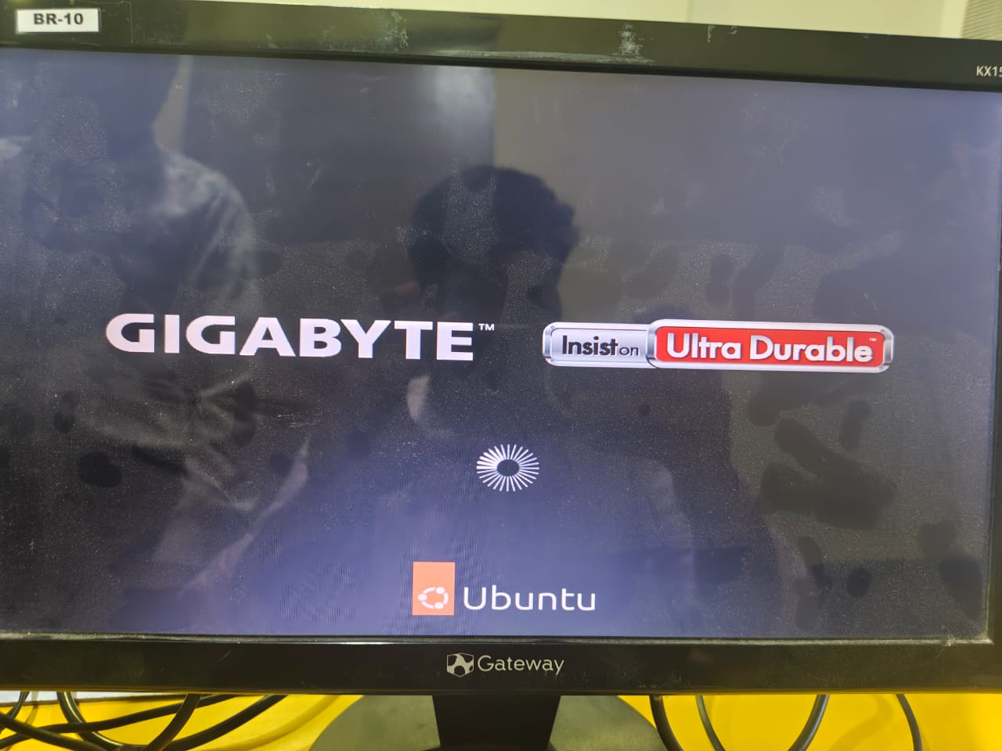

TASK3.On a macOS device (or using a macOS virtual machine), open 'System Preferences' and change the desktop wallpaper, then adjust the system language to Hindi or Gujarati.<br><br><em><strong>Hint:</strong> Find 'Language & Region' in System Preferences to add or change languages.</em>
WALLPAPER CHANGE-
1.click on apple menu in top left
2.select system preferences
3.click on wallpaper
4.choose any wallpaper from available option
5.click wallpaper for apply
6.verfy from background that wallpaper has changed
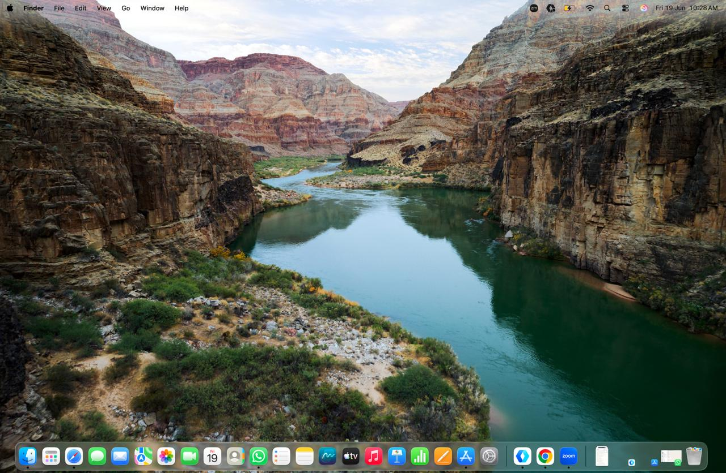
SYSTEM LANGUAGE CHANGE-
1.Open system preferences
2.click on general-region and language
3.click + to add language
4.select hindi from list
5.click add
6.choose hindi as primary language
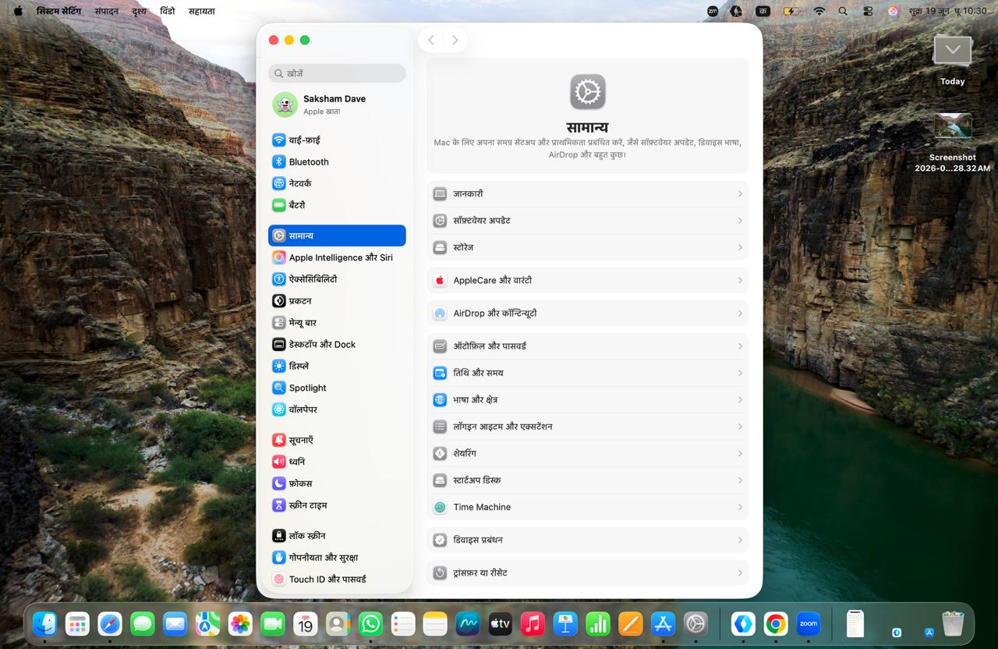

TASK4. Install a fresh copy of Ubuntu Linux (real or virtual machine) and create a new user account named 'gamer'. After installation, enable automatic login for this user and take a screenshot of the login screen showing the username.
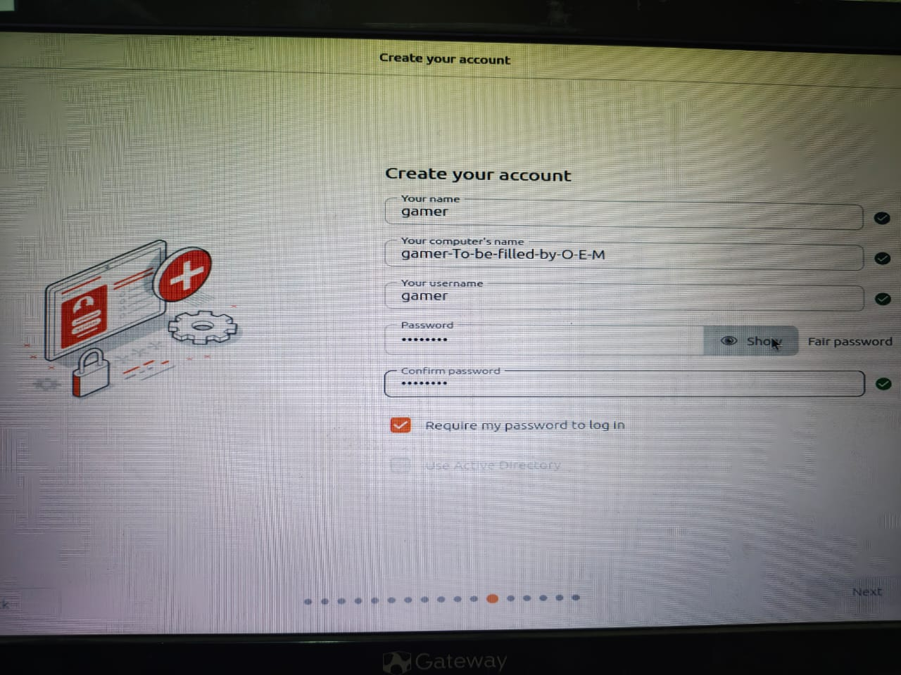
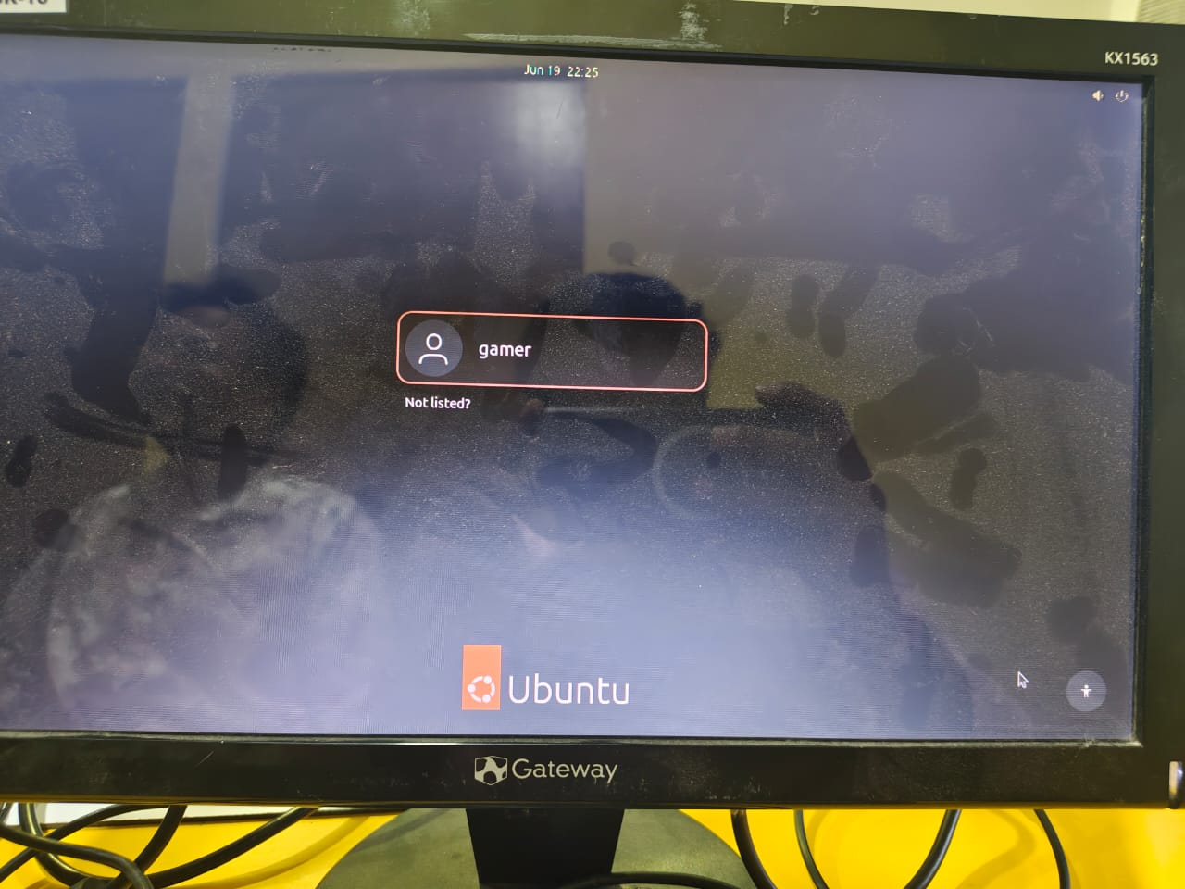

TASK5. Use ChatGPT to generate a step-by-step guide for installing Windows 10 on a laptop, including partitioning tips and post-installation settings for privacy and updates. Follow the guide and note any steps that were unclear or missing.
Requirements
- Windows 10 ISO
- Bootable USB (8 GB or larger)
- Backup of important files
Installation Steps
Step 1: Create Bootable USB
- Download Windows 10 ISO from Microsoft.
- Use Rufus to create a bootable USB.
Step 2: Boot from USB
- Insert USB drive.
- Restart the laptop.
- Open Boot Menu (F12/F10/Esc depending on device).
- Select USB drive.
Step 3: Start Installation
- Select language, time, and keyboard settings.
- Click Install Now.
Step 4: Partitioning Tips
- Select Custom Installation.
- Delete old partitions only if a fresh installation is required.
- Create:
  - C Drive: 100–150 GB for Windows
  - Remaining space for Data (D Drive)
- Select the C partition and click Next.
Step 5: Complete Installation
- Wait for files to copy.
- System will restart several times.
- Complete setup wizard.
Step 6: Privacy Settings
- Disable unnecessary location tracking.
- Turn off advertising ID if not required.
- Review diagnostic data options.
Step 7: Updates
- Connect to the internet.
- Open Settings → Update & Security.
- Install all available updates.

